

Melkbosstrand High School
Grade 10 | Computer Applications Technology |  | Term 3  2026
Time: 1 hour | TASK 4  Practical test |  | Marks: 50
Examiner: R. Rabe |  | Moderator: F Pretorius
Instructions and information
- This question paper consists of WORD-PROCESSING, EXCEL-SPREADSHEET and WEB DESIGN (HTML) questions.
- Note that you will not be allowed to leave the venue before the end of the session.
- Make sure that you save each document using the given file names. Save your work at regular intervals.
- At the end of the examination, you should make sure that ALL the files are saved on the network as explained to you by the teacher. Make sure that all files can be read. Do NOT save unnecessary files/folders. Do NOT hand in duplicate answer files/folders.
- Read through each question before answering or solving the problem. Do not do more than is required by the question.
- During the examination, you may make use of the help facilities of the programs which you are using. You may not use any other resource material.
- Note that if data is derived from a previous question which you cannot answer, you should still proceed with the questions that follow.
- Answer ALL the questions.
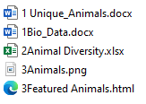
- You will receive together with the question paper an examination
folder called TEST DATA Gr10 Term 3, which contains the
following files:

QUESTION 1: WORD-PROCESSING
SCENARIO: UNIQUE ANIMALS
Imagine you are a young wildlife explorer travelling across the globe to study some of the world's most unique animals. You decide to create a campaign called "Celebrate Our Unique Animals" to educate people about the importance of protecting these rare and extraordinary species for future generations.


Open the 1Unique_Animals word-processing document.
1.1 | Change the document layout as follows:
 | 1.1.1 | Set the left and right margins of the document at 3 cm and 2 cm respectively. Keep all other margins as they are. |  | (2)
 | 1.1.2 | Change the size of the document to A4. |  | (1)
 | 1.1.3 | Apply a light green colour to all the pages of the document. |  | (1)
1.2 | Insert page numbers in the middle of the bottom section of the document. The page numbers should display as follows: |  |  | (3)
1.3 | Apply the Heading 2 style to all paragraph headings with animal names. |  |  | (2)
1.4 | Insert a hyperlink on the word ‘biodiversity’ in the first paragraph that will link to 1Bio_Data.docx |  |  | (3)
1.5 | Apply the following paragraph formatting to the second paragraph starting with “One of the strangest…” and ending with “…maintaining food webs”:
 | 1.5.1 |  | Justify the body text. | (1)
 | 1.5.2 |  | Apply 1.5 lines spacing and 6 pt spacing after paragraphs. | (2)
1.6 | Find the phrase 'Where it is found:' underneath the heading Platypus. Add a comment to the phrase 'Where it is found:', the comment should state “Animal sections”. |  |  | (2)
1.7 | Convert the section for the Narwhal and Quokka animals to appear as follows:  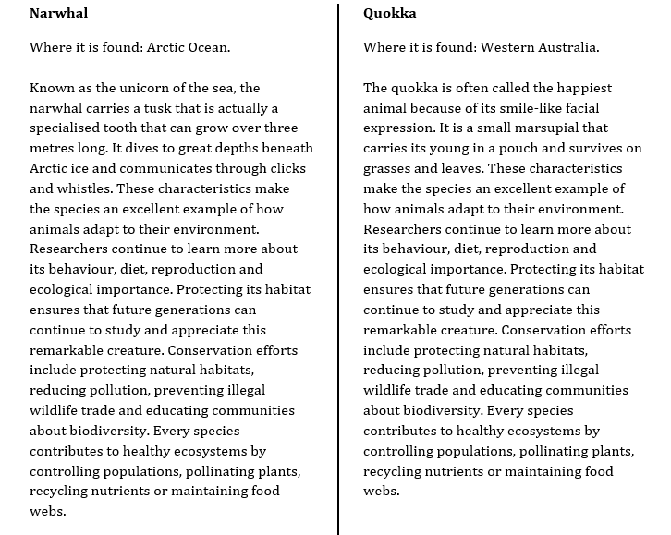 |  |  | (3)
 |  |  |  | [20]

QUESTION 2: SPREADSHEETS
_{NOTE:}
- Use formulae and/or functions for ALL calculations in the spreadsheet.
- Use absolute cell references ONLY where it is required by the question to ensure that formulae are correct when you copy it to other cells in the spreadsheet.
- Insert formulae and/or functions in such a manner that the correct results will still be obtained even if the existing data changes.
- Should you need to use building blocks, use the allocated space in the spreadsheet.
Open the 2Animal Diversity spreadsheet.
2.1 | Apply the following formatting to the spreadsheet:
 | 2.1.1 | Rename Sheet1 to 'More Animals' | (1)
 | 2.1.2 | Sort the information in Sheet2 to display in alphabetical order according to conservation status. | (2)
2.2 | Work in the Animals worksheet.
2.3 | Calculate the average top speed of all the animals. Display your answer in cell B63. |  | (2)
2.4 | Insert a function in cell B64 to determine the highest symbolic adoption cost. |  | (2)
2.5 | Count the number of animal names that are featured in the worksheet. Insert a function in cell B65 to display the answer. |  | (2)
2.6 | Insert a function in cell B66 to display the value that appears the most in the Average Lifespan (years) column. Display your answer with two decimals. |  | (3)
2.7 | Count the empty cells in the Estimated Population column. Display your answer in cell B67. |  | (2)
2.8 | Correct the formula in cell B68 that is trying to display the difference in population between the Narwhal and the Red Panda. |  | (1)
2.9 | Insert today's date in cell B69 by using a function. |  | (1)
2.10 | Insert a function in cell B70 to indicate the number of animals that have an average life span of 40 years and more. |  | (4)
 |  |  | [20]
QUESTION 3: WEB DESIGN (HTML)
NOTE:
- You may NOT use a word-processing program such as Word to answer the HTML questions.
- An HTML tag sheet has been attached for reference.
- All files needed to complete this question are found in the examination folder.
- Question numbers appear as comments in the coding to guide you where to insert the answer(s). DO NOT delete these comments.

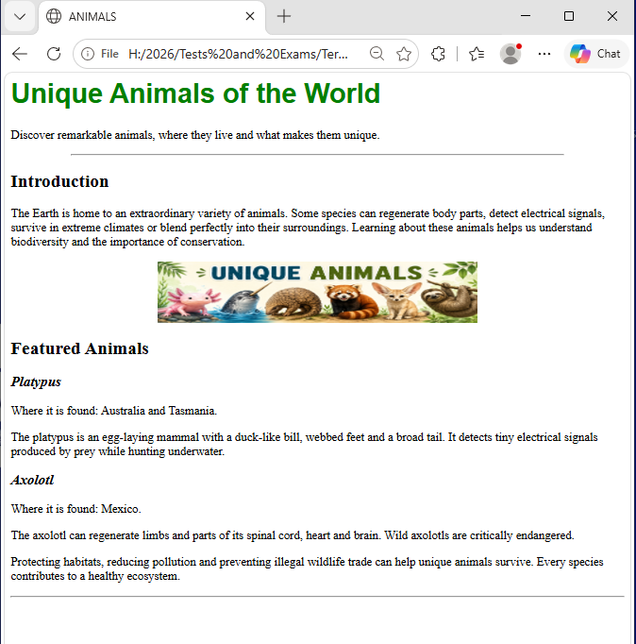
Open the incomplete 3Featured Animals.html file in a web browser and in a text/HTML editor. Your final page should look like the example below.

3.1 | Change the body background colour from white to yellow. | (1)
3.2 | Use a <font> tag with the appropriate attributes to display the main heading ‘Unique Animals of the World’  - in Arial  - size 6  - green. | (4)
3.3 | Change the horizontal line below the main heading to display across 80% of the page. | (1)
3.4 | Format all <h3> section headings in italics. | (2)
3.5 | Insert a second horizontal rule immediately after the last paragraph. | (1)
 | ONE mark will be allocated for the correct use of closing tags and correct nesting in the web page. | (1)
 |  | [10]

GRAND TOTAL: 50 MARKS

